Using Go Figure with the Spike device

When using Go Figure with the Ikegps Spike device you first need to make sure you have both Go Figure and the Spike app installed on your iPad. Both can be downloaded directly from the App Store. As long as both apps are installed and the Spike device is on all you need to do is access the camera inside Go Figure and all data will transfer automatically.

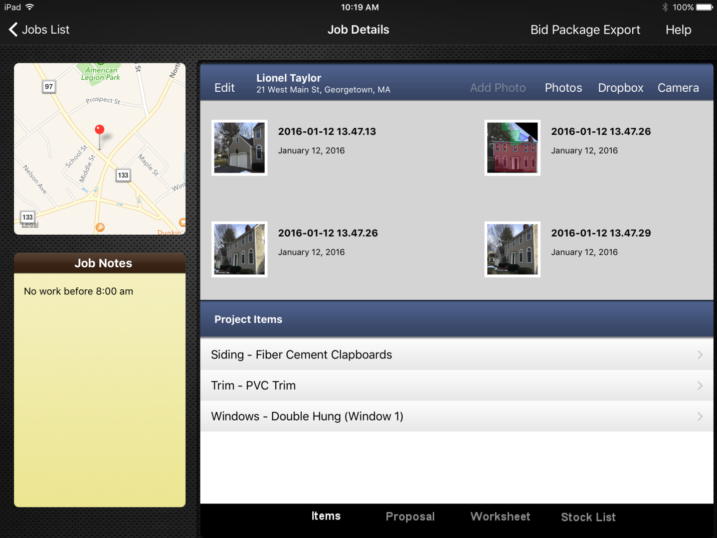

When you open the camera in Go Figure the first time you will be prompted to connect the Spike device. Once you have tapped on the connect bar you should see crosshairs in the center of the camera with the distance below. (For connection issues visit http://support.ikegps.com/) Simply point the crosshairs at the side of the house you need to measure and take a picture. You can take as many pictures in a row as you would like but remember to hit the black checkmark in the top right of the screen when you’re done to import the pictures.
Next open one of the pictures in the Job Details screen by touching it and choose the scale button in the bottom right corner.
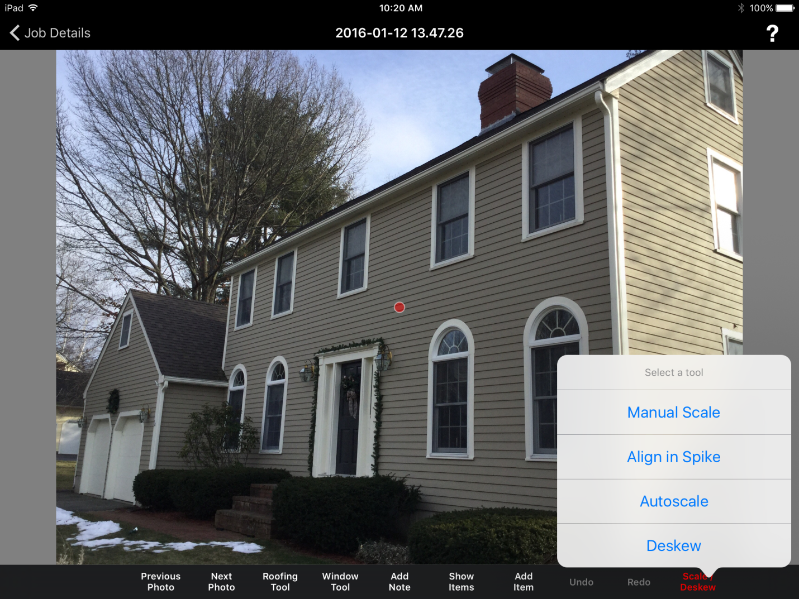
In the dialog box hit Align in Spike. This will take you to the screen where you set the alignment rectangle. The alignment rectangle can be adjusted by dragging any of the points on the four corners. Set the rectangle on the side of the house you will be measuring. Set the sides on the cornerboards and the top and bottom on the bottom siding course and the eave. If you are doing the gable end just align the top with a siding course part way up the gable. When the photo is deskewed and cropped it will include 10% of the area outside the alignment rectangle on the sides and bottom and 50% above the top. When your alignment box is set hit the done button at the top right and the photo will deskew and set the scale so you can start your takeoff.
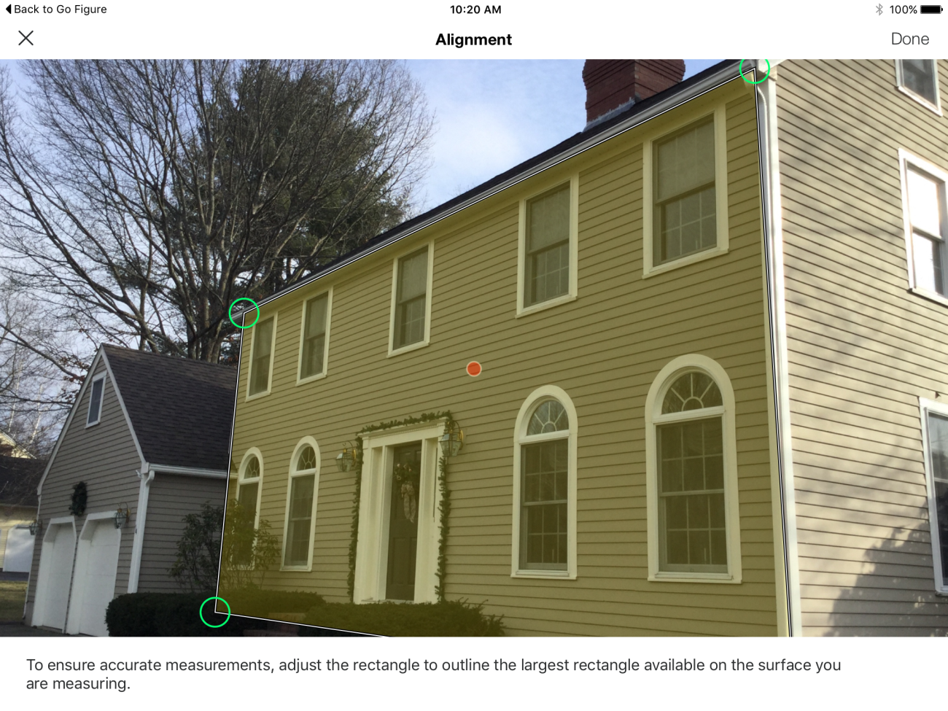
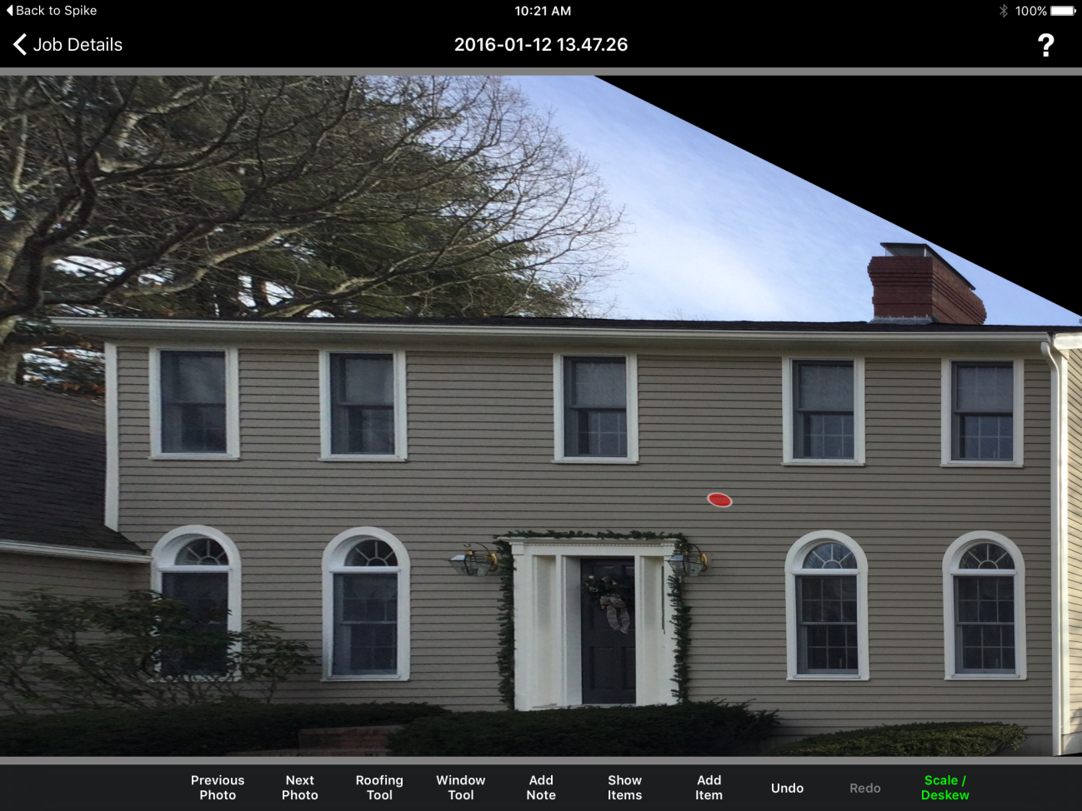
Start by hitting the Add Item button on the task bar. This will open a menu with
Area, Linear and Count. Choose the unit of measurement that corresponds to the
item you will be estimating. For instance if you are bidding a siding job choose
Area, on the next menu choose siding and then the type of siding. Once you have
chosen the item for your takeoff simply use the touchscreen to highlight your
areas.
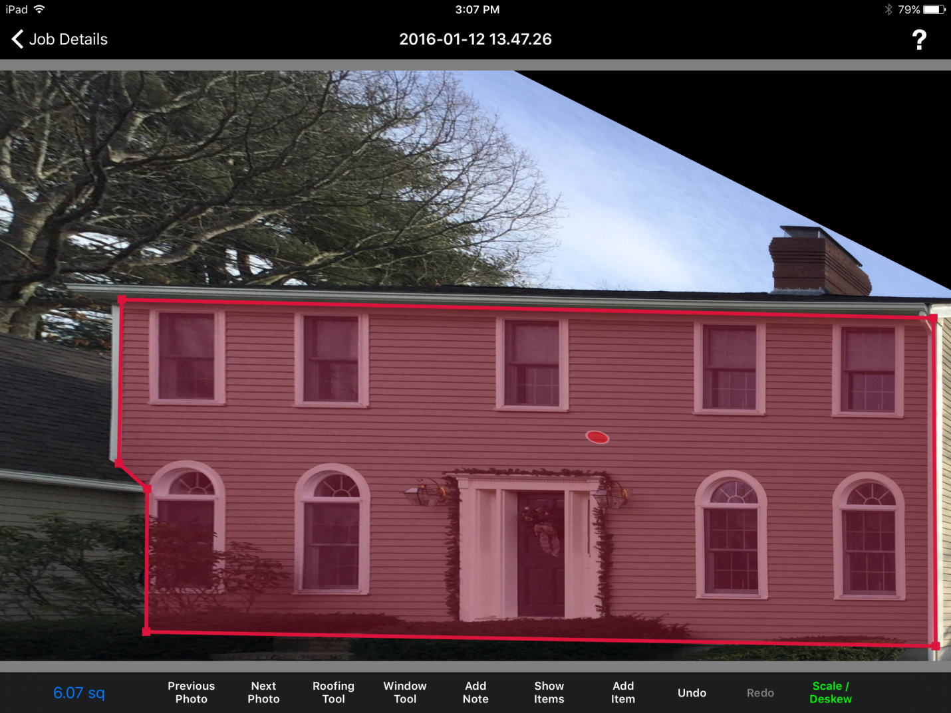
Start by tapping the bottom right corner of the side. Then tap the top of the
cornerboard, then the left side of the eave and down the cornerboard. As you touch
each point a line will appear tracing the outline of the side.
Once the outline is complete and the box is closed the quantity of siding will
appear in the bottom left corner of the screen.
To calculate the trim hit the Add Item button on the taskbar then choose Linear
and Trim and finally the kind of trim. Touch the bottom of the trim board and
then the top and the points will connect measuring that piece of trim. When you
are measuring a piece of trim and you want to end the line simply long press on
the final point. Put your finger on the final point and hold it there for 1-2 seconds,
this will terminate the line and allow you to start another anywhere on the
picture. It might take a little practice to get the feel for it. If you end up with an
unwanted line just hit the undo button on the taskbar and try again.
To count items, such as windows, doors, lights etc. hit the Add Item button,
choose Count and choose the item to count. Then touch wherever in the picture
you want to count the item.
As you go through the photos doing your takeoff remember that you only need
to create an item once. After you create an item it will be added to the items list
for that job and can be accessed by hitting the Show Items button.
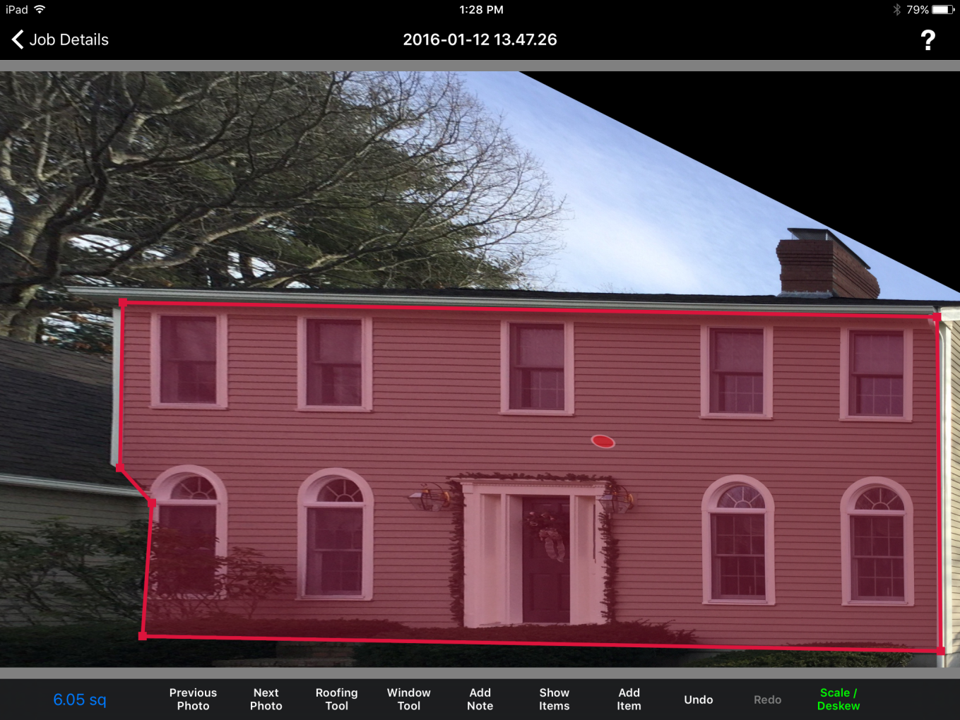

When you have finished your takeoff hit the Job Details button in the top left
corner of the screen. Locate the “Worksheet” button at the bottom of the page
and tap on it.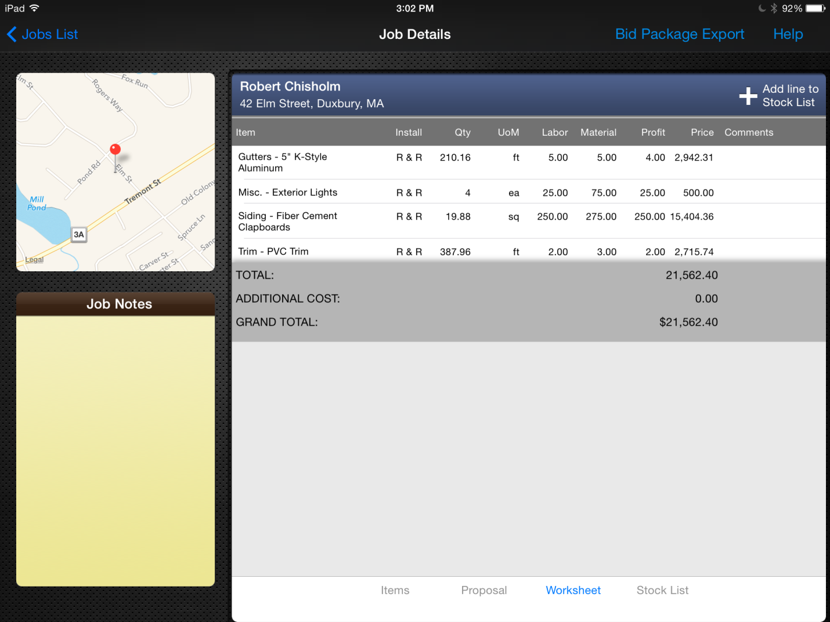
This is where you will enter the price for each item of your takeoff. Touch the
space to the right of any item and the pricing box will open. Enter your pricing and
Go Figure will multiply it by the quantities you’ve calculated and give you the total
price for the job. Pricing can also be entered from your account on the Go Figure website.
You can also touch the number to the right of “Additional Cost”
and add in any sum you’d like.
At the top of the Job Details is the “Bid Export Package”. This is the report on
the job that includes all the items you created and the quantities of the items
broken out by each side of the house. The report also includes pricing and a copy
of the proposal that can be printed or emailed back to the office.

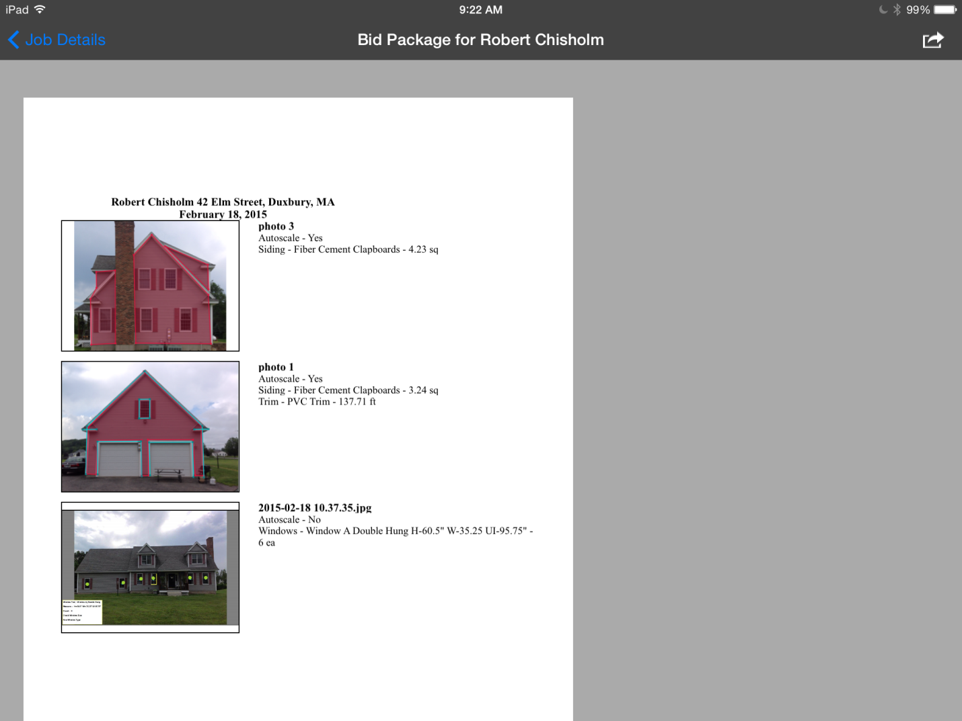

Below are some helpful tips to get you started. For more information take a look
at the instructional videos on our website gofigureapp.net . These can also be
accessed from the “Instructional Videos” button on the Jobs List page of the app.

Go Figure Tips and Tricks
- When taking a picture try to be as perpendicular to the house as possible. Go Figure can handle significantly skewed photos easily but straighter is better.
- When drawing an item that is close to another item either zoom in using the two finger pinch to zoom or draw it off to the side and drag it into place. This will prevent you from accidently selecting the other item as you draw.
- When terminating a linear simply long press on the final point for 1-2 seconds.
- If you accidentally create an unwanted point or line use the undo button to remove it.
- When calculating trim around windows draw one window then long press on it and choose duplicate object. This will allow you to do multiple windows quickly and easily.
- If you want to be as accurate as possible take a picture of each “plane” of the house (i.e. each surface of a bumpout) if you choose not to, simply overdraw any portion that is recessed to account for the greater distance.
- You can use the pictures from the Bid Export Package to show your client exactly where the work is to be done. Just be sure to remove the worksheet and pricing first.

